HCI

Assignment 2

“Buckingham Estate”

By

Ian Whittemore

**User Analysis**

Buckingham Estate (BE) company will be a software system that will be used to manage renting properties as well as managing their customers. BE system will be for administrators only.

The user analysis will be targeting users such as the administrators of Buckingham Estate. They will be storing and using other information such as: companies, landlords/landladies (majority 40+ years old) or tenants (majority 21+ years old), to view with ease and simplify all the data as well as making the workload of the administrators easier to input as they may not have much experience using software similar to this.

The user’s requirements for companies and landlords/landladies will be data relating to the property, such as the properties address, number of bedrooms, kitchens, rest rooms, utilities, renting price and the owners name. This data will then be entered into the system by the admin or it can be stored for later inputting if the customer sends the information via email. There will also be a company’s/landlords/landlady’s tab with their personal information, this being their name, gender, age, contact number, address, post code and email address.

The user’s requirements for renting a property will be different as it will require tenants to sign a rental agreement, this being a formal contract with tenants. This will have a unique number to specify which agreement is for who and where. The agreement will include the start date and duration of the occupation, the administrative fee, the amounts for security deposit and monthly rent, and their payment method for rent, for example: bank transfer, cheque, direct debit. Another tab will be available to refer to the personal information of the tenant such as their name, gender, age, number, email, unique number (which is the specific number related to the property they renting and rental agreement).

Another user requirement is the ability to search. This search feature will allow the administrators to search using the unique number which will search for the tenants related to the unique number. Search using the owners name and bring up their personal information. One can also search for property and read all information relating to the property.

The arrange viewing tab is to be used when a client wishes to view a property. This allowing the client to choose a date and location to view the property which is then put into a list that will be able to be viewed by the administrators to see upcoming planned views.

Lastly, administrators have the ability to see which properties are coming up for renewal or expiry so they know which properties they can start marketing and searching for new tenants to occupy the properties.

The aim of this software is catering for the users’ needs and desires, therefore the software will aim to manage ( view, edit, delete, add) all customers information such as landlords/landladies or companies (i.e. real estate) as well as managing all property’s information. There will also be a function to arrange a property viewing. Lastly a find/search function to find/search for agreements that are expired or properties available for future tenants. Property information and personal information regarding tenants or companies/landladies/ landlords can be searched for using this function.

**Interaction style**

The software will use the *form fill-in* style. The reason for this is because the form *fill-in* style is a form with free slots that require the user to input data and from this data it will perform the task required. This is a very simple interface that fits perfectly for the system as the aim is not to be complex but rather to simplify the work for processing. This interaction style is good for data entry and data verification, which is needed for the BE company as mentioned for inputting data with ease but also to check the data and see if its verified, this will help to eliminate data errors that could occur such as confusing two landlords’ properties etc.

**Task analysis – HTA**

The HTA is as follows

(0) Manage Properties, Customers, tenants, Arrange Viewing, Search

(1) Open the software application

(2) Enter employee number and password

(2.1) If details are wrong – re enter

(3) If correct then opens main form

(3.1.1) Opens on Property tab

(3.1.2) Enter information and select Operation "Add", "Update”, “Delete"

(3.1.3) Information is displayed in list view box

(3.1.4) Select Next to go to next tab, or exit to leave application

(3.2) Select Tenant tab

(3.2.1) Enter information and select Operation "Add", "Update”, “Delete"

(3.2.2) Information is displayed in list view box

(3.2.3) Click on agreement button

(3.2.3.1) Form to input further financial details’

(3.2.3.2) Click on “Print Sign Agreement”

(3.2.3.2.1) Opens the Legal signature image

(3.2.3.2.2) Select print to print image

(3.3.3.2.3) Select exit to go back to previous form

(3.2.3.3) Select exit to go back to tenant tab

(3.2.4) Select “Next” to go to next tab, “Back” to go to previous tab or “Exit” to leave application

(3.3) Select Companies/Landlords tab

(3.3.1) Enter information and select Operation "Add", "Update”, “Delete"

(3.3.2) Information is displayed in list view box

(3.3.3) Select Next to go to next tab, or exit to leave application

(3.4) Select Search tab

(3.4.1) Select a search button and enter information

(3.4.2) Click search button

(3.4.3) Select Next to go to next tab, or exit to leave application

(3.5) Select Arrange Viewing

(3.5.1) Enter information and select Operation "Add", "Update”, “Delete"

(3.5.2) Information is displayed in list view box

(3.5.3) Select Next to go to next tab, or exit to leave application

(3.6) Select Available Property

(3.6.1) Double click on address to bring up arrange viewing tab

(3.6.2) Select Next to go to next tab, or exit to leave application

(3.7) Select near expiry property

(3.7.1) Double click on address to bring up arrange viewing tab

(3.7.2) Select Next to go to next tab, or exit to leave application

4 Exit application.

**Plan**

Plan (0) Do (1)

Plan 3.1 do 3.1.1 do 3.1.2 do 3.1.3, if needed do 3.1.4

Plan 3.2, select either 3.2.1 or 3.2.2 if 3.2.1 do 3.2.2 do 3.2.4 if 3.2.2 do 3.2.3.2.1 if 3.2.3.2.2 do 3.3.3.2.3 or return 3.2.4

Plan 3.3 do 3.3.1 do 3.3.2, if needed do 3.3.3

Plan 3.4 do 3.4.1 do 3.4.2, if needed do 3.4.3

Plan 3.5 do 3.5.1 do 3.5.2, if needed do 3.5.3

Plan 3.6 do 3.6.1, if needed do 3.6.2

Plan 3.7 do 3.7.1, if needed do 3.7.2

(4) Once program is not in use or needed

**STN to manage tenant’s information**

Select other tabs or function if further tasks need to be processed or saved

Stays on current tab

Click add button

Add information as needed

Cursor moved to correct input section to fill info

System response

User input

Display information

Click tenant tab to show tenant information

Tenant

Tab open

Open Software application

Login screen

**Design rough View**

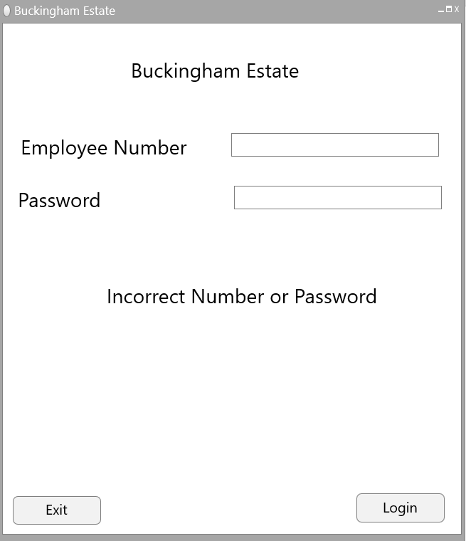

Login screen

This is the first form that is used to be the login screen so that unauthorised people cannot gain access. If the user inputs the wrong employee number or password, it will display a message stating, “Incorrect number or password “and will keep showing this form until the user enters the correct details. The form will also be labelled by the name of the company,” Buckingham Estate”. The form will also be allowing the user to exit the application if they so desire.

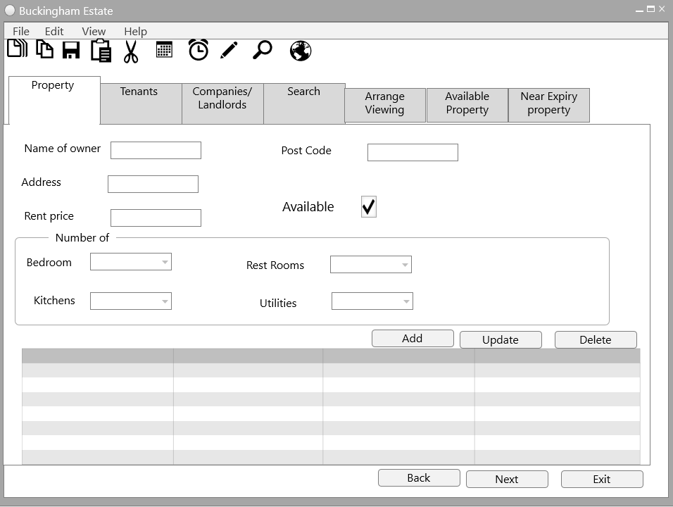

Main form – Property tab

This form will open if the user is authorised to access the program. In this form it will use tab controls for easy access within the program. It will have a tool strip to help access certain areas but will also use icons on the top to switch between tabs, if the user does not wish to click those icons then they may simply use the “Back “or “Next “button to switch between tabs, or click exit to exit the entire program, Theses three buttons will be consistent within all the tabs of the program.

The first tab will open up to the property details which will include all information required for the property which will then be used to store in a list box that can be used later for updating or deleting.

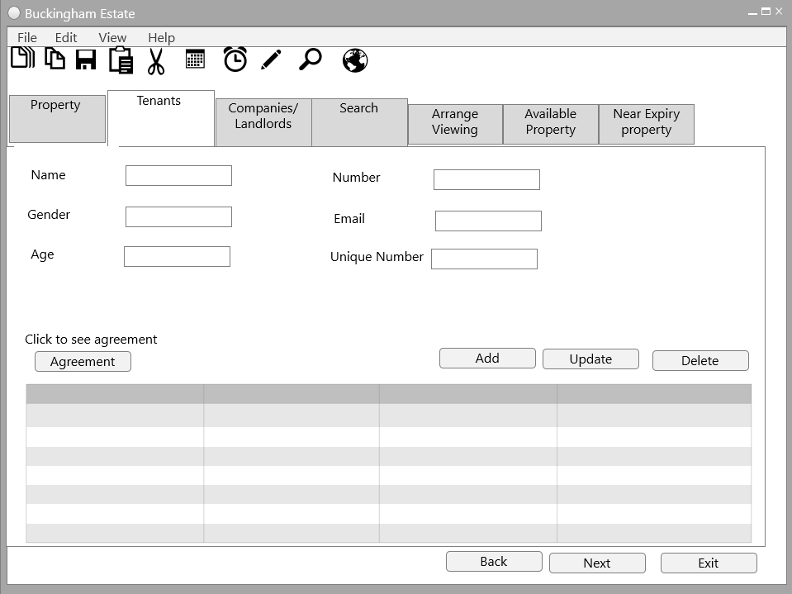

Main form – tenant tab

Similar to the property tab, this tab selection will be for the information regarding tenants that the user will be able to add, update or delete tenant information, or to simply store to view for later use. This tenant function also has a button called “Agreement” that will bring up a new form.

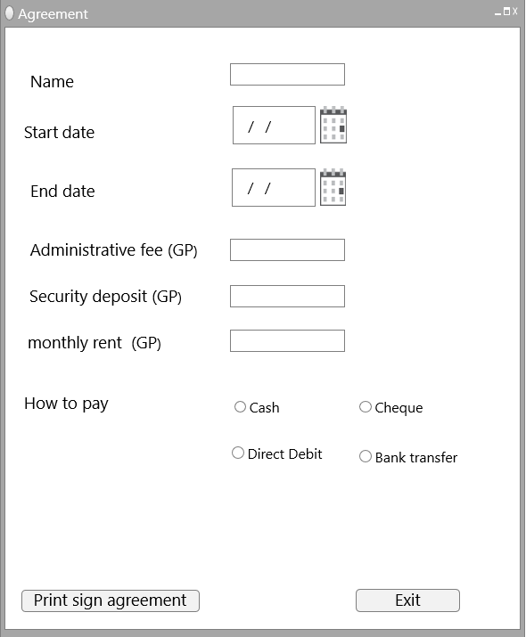

Agreement form

This form opens if the user clicks on the previous tab, “Tenants”. It will display further information regarding the agreement of the tenants, this relating to the dates of the agreement and the money needed as well the way they will be paying. This form allows the user to click on the exit button that will close this form but will still keep the other main form open for further use. There is another button that will allow the user to print the sign agreement which will open a new form.

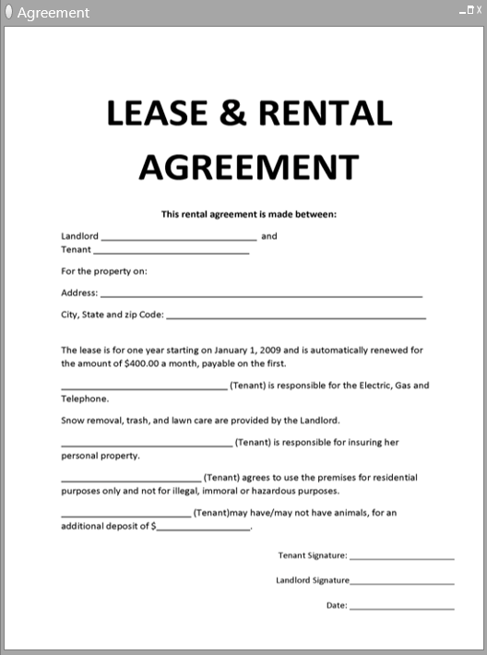

Sign agreement form

This form opens if the user clicks on the button in the previous form,” Agreement”, that will show the lease and rent agreement that is available to preview and print in order to get the tenants signature and create a legal contract.

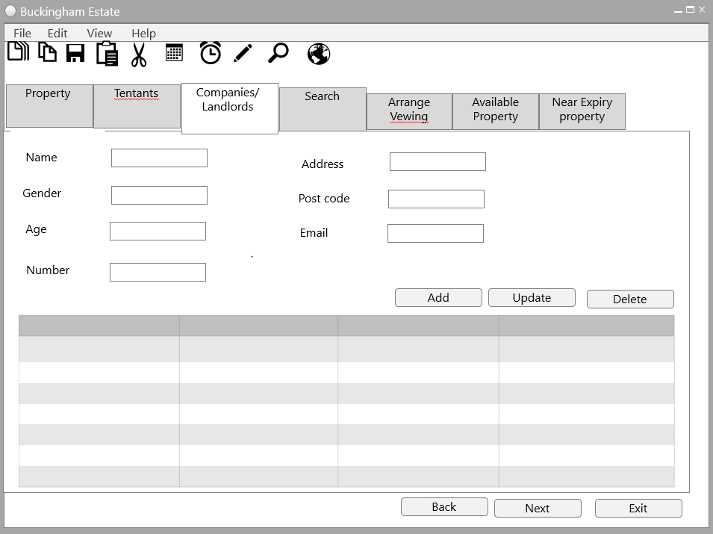

Main form – Companies/landlords

Back to the main form, another tab function is the companies/landlords tab, this allows the user to add personal details regarding the companies or landlords. It also allows the ability to have a button to update their information or delete.

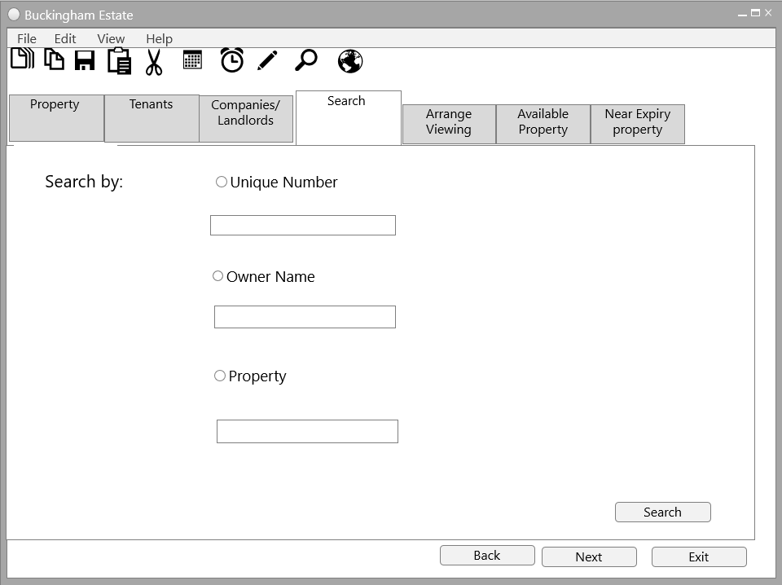

Main form – Search

This tab is used to search for specific details. The first one is used to search for tenants related to the unique number given to the tenant, the other search function is to search directly for the owner’s name, this bringing up all their information, lastly is to search directly for property and display information related to it. If the user clicks on the radio button they wish to search for, then it will display a text box for the user to enter. This function will not allow for multiple inputs of different searches, so the user can only enter in one of the options. E.g.: user can not search for unique number and owner name.

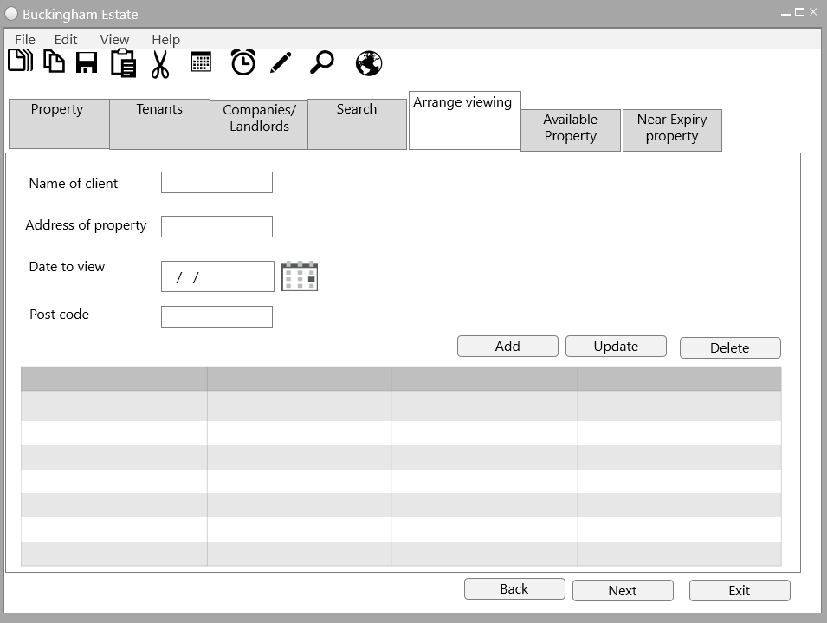

Main form – Arrange Viewing

This tab is used to arrange a viewing for a property, it will specify which property and when. This will allow the use of storing the planned arrangements and the ability to update if need be or to delete.

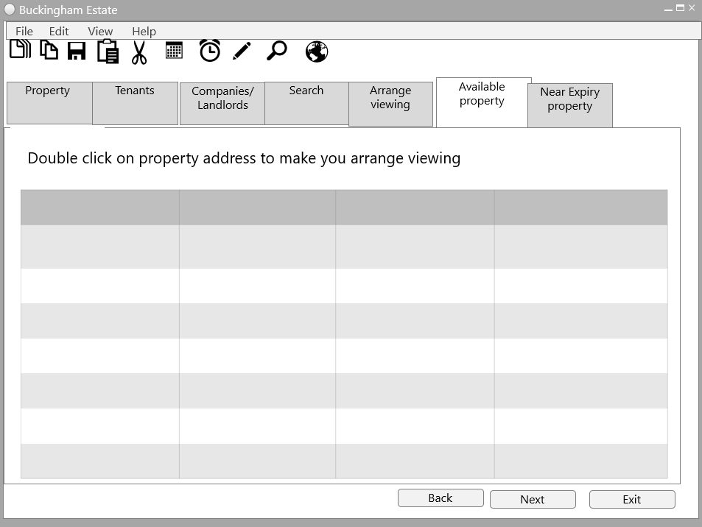

Main form – Available property

This tab is used to see what property is available and if the user wishes to find out more they can double click on the property to see arrange a viewing.

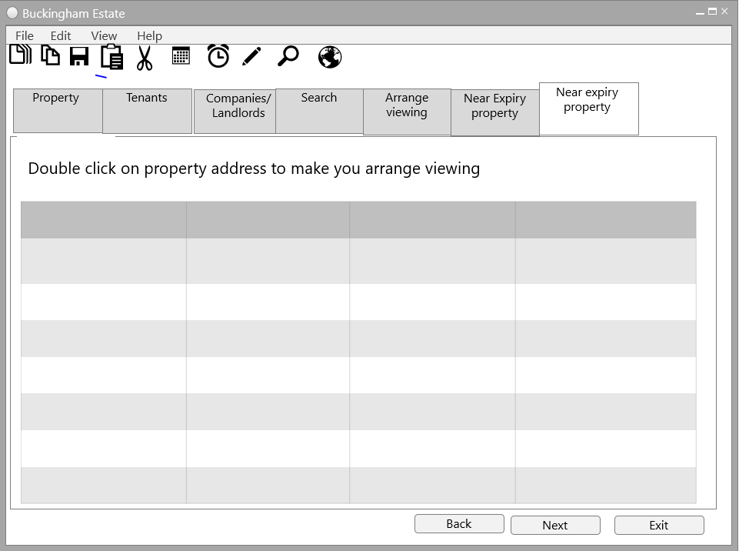

Main form – Near expiry property

This tab is used to see what property is near expiry and if the user wishes to find out more they can double click on the property to see arrange a viewing.

**Design View**

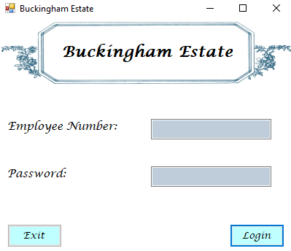

First form

This form is the main opening form, it is used as a login screen to authorize users getting into the system. The colours are light blues with grey as this is appealing so the user wants to use the system and gives a luxury feel to the user, as well the title is the name of the program. To make it more professional. The layout is a nice labelled image of “Buckingham Estate” with labels and text boxes all in symmetrical alignment to show organisation, these text boxes are for the users input. Once the user has inputted everything then they click on “Login” button to go to the main form, or they can exit the application if they desire by clicking the “Exit” button. If the user enters the wrong then this form below will be displayed.

For demonstration purposes the Employee Number is: 1234 and the Password is :1234

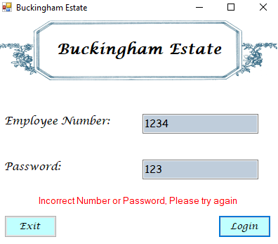

First form - Error

This message is displayed in a dark red to show that the user has entered the wrong employee number or password and to try again.

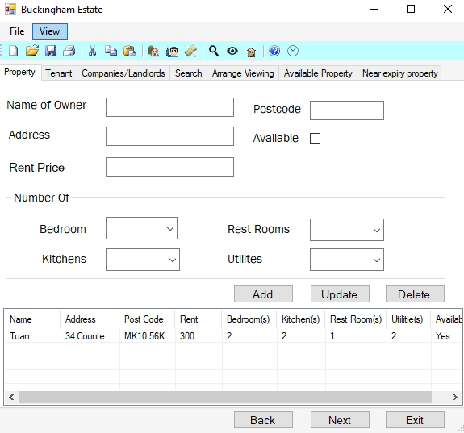

Main form

This is the main form for the program and is how the user will access all the features within the program. This program uses tab controls in order to change the features. This form is consistent with all the other tabs, so there is always a “back”, “Next” button that will allow the user to go back and forth between the tabs, or they can use the “Exit” to exit the whole application. The form includes a blue tool strip that has icons that match the different tabs via their functions, for example the icon with the house links to the property tab, so if the user clicks on it then they will be shown the property tab. Throughout the main form it uses rather large text for clear understanding and majority of the fields use a tool tip to help navigate the user.

Property tab

The picture above is the tab for the property information. This will be all the details needed for the property and will be using text boxes to allow user input and a check box to see if a property is available or not for other functions later on. Also includes a group box that shows the number of rooms in the property (each room has an option between 1 – 8+). This tab also allows for the user to add the information in the list box and update and delete any stored information in the list box.

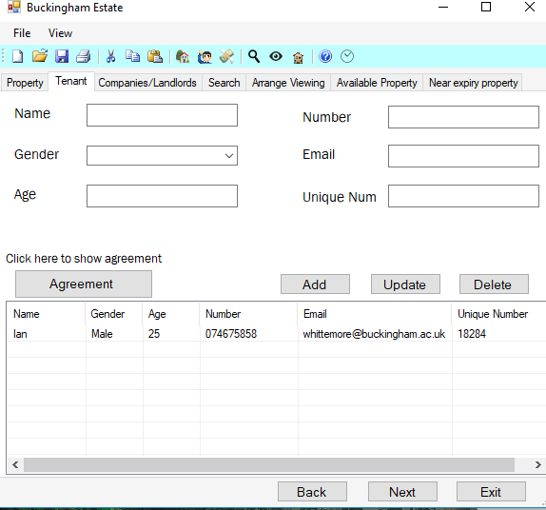

Tenant

This tab is used to gain personal information regarding the tenant and allows for the easy input for their gender by using a dropdown box or they can enter it manually. The user assigns a unique number to the tenant for identifying them later on. This tab has the ability to add, update or delete a tenant. The unique feature of this tab is to click on the agreement tab that brings the user to a new form

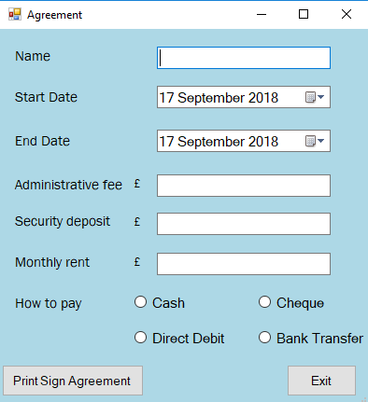

Tenant Agreement

This form is consisting of a light blue background to stand out and make it appear to the user that this is a rather important set of extra information needed. This form is for further information regarding the financial and more specific information about the agreement of the property. This form also includes the option to show the legal documentation required for signing. The user can return to the main form by clicking the exit button.

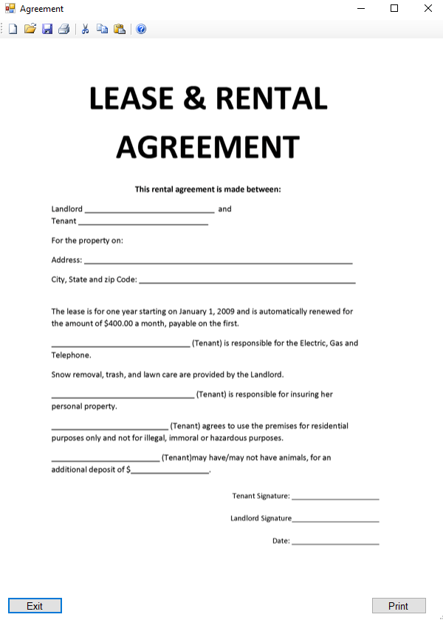

legal Agreement form

This form is appearing only if the user clicks on the previous form “print sign agreement”, this then appears the following image which is a template of where the legal signatures are required, thus providing a legal contract. The user may then click print or can simply click exit to go back to the previous form.

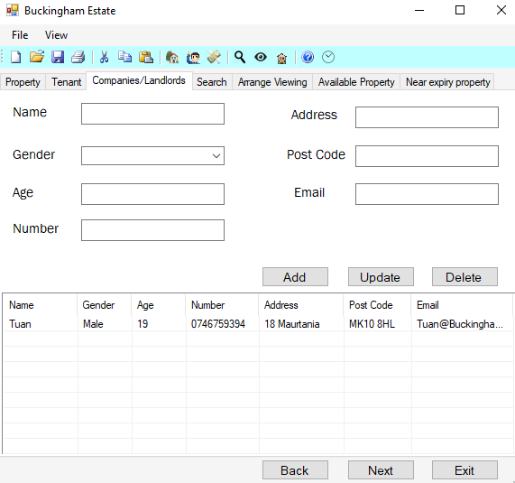

Companies/Landlords/Landladies

This tab is used to gain personal information regarding the companies, landlords or landladies. Similar like the tenant tab it allows for easy input of the gender as it uses a drop-down box. This tab has the ability to add, update or delete a specific person, and all the clients are listed down below for easy viewing and access.

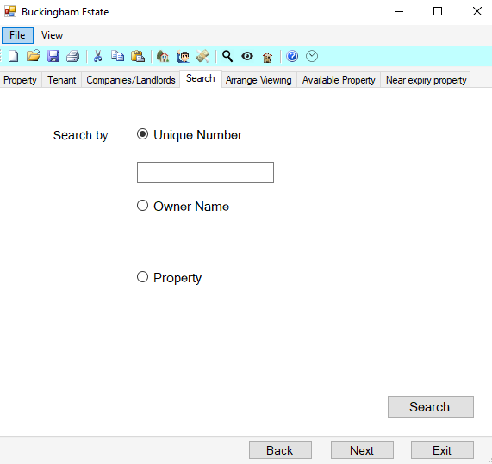

Search

This tab is used to search for specific information or people. The unique feature of this tab is that only one radio button can be clicked, and only one text box will be shown, this way the use cannot enter multiple values in different search boxes. An example of the search feature is: Enter 12345 in the unique number, then click submit, once clicked it will open the tenant tab with all information regarding the tenant associated with the unique number. The owner name search will open the companies/Landlords tab and lastly the property search will open the property tab.

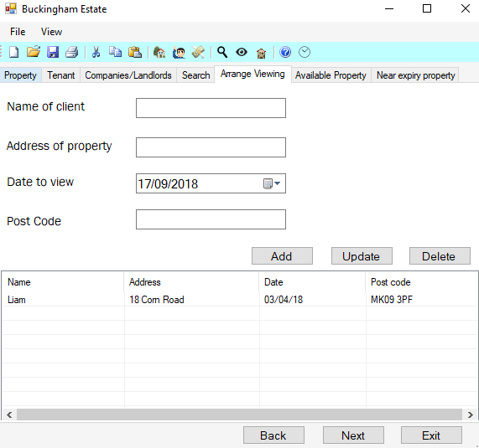

Arrange viewing

This tab is used to create an arranged viewing of a property, this tab will be needing the name of the potential client, the address of the property they wish to view, the date to view the property and the post code of the property. This tab allows the user to add information of a viewing, and the ability to update or delete a viewing.

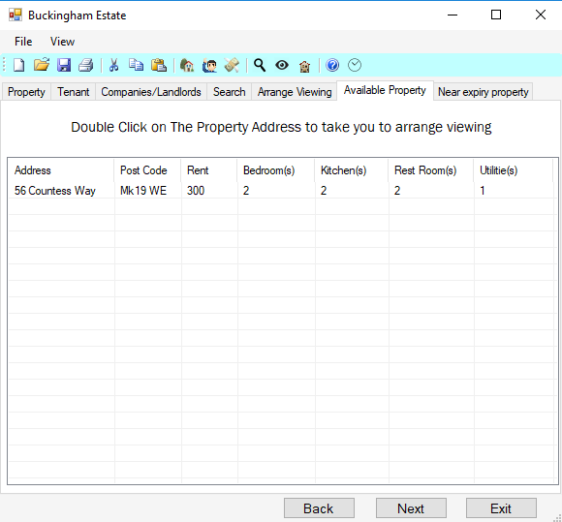

Available property

This tab is used to view all properties that are available, if the user desires they may double click on the property address which will take them to the arranged viewing tab to allow them to make a viewing of the property.

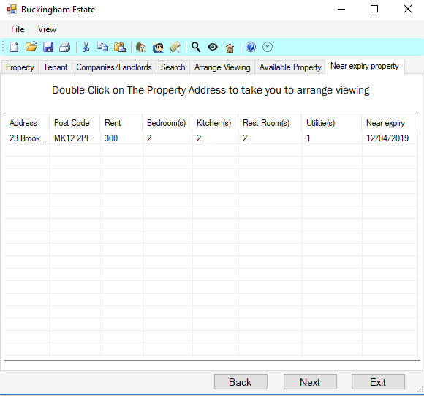

Near expiry property

This tab is used to view all properties that are near expiry, this then helps the user see what is the upcoming property that will be available and arrange viewings/ potential clients, this then helping to get a new tenant in the property sooner.

Summary

Buckingham Estate program will help make work easier for the administrators of Buckingham Estate to navigate and find information.

The art style /look and feel of the program is a luxury type feel that makes the user want to engage with the software, plus makes viewing easier with larger buttons and text for people to read. This helping maintains many interface conventions, such as text boxes and labels are on the left as people read left to right, the program also is clear enough that there is no strain on the eyes.

The use of tabs is easy to help navigate as there are tool tips on majority of the text boxes and buttons to help the user as well as the labels are self-explanatory, this software also helps with the performance of the machine as everything is loaded at once.

Overall, I am pleased with the prototype of the program and enjoyed every minute in the designing and usage of the program’s functions